1.9 Genes Work Together and Are Regulated Exit Ticket Name ___________________________ Hr: ___

In the table below describe how the TYR and MC1R genes work together and are regulated to produce the broad range of skin colors available in humans. How do those genes impact the proteins and how do those proteins impact the trait?

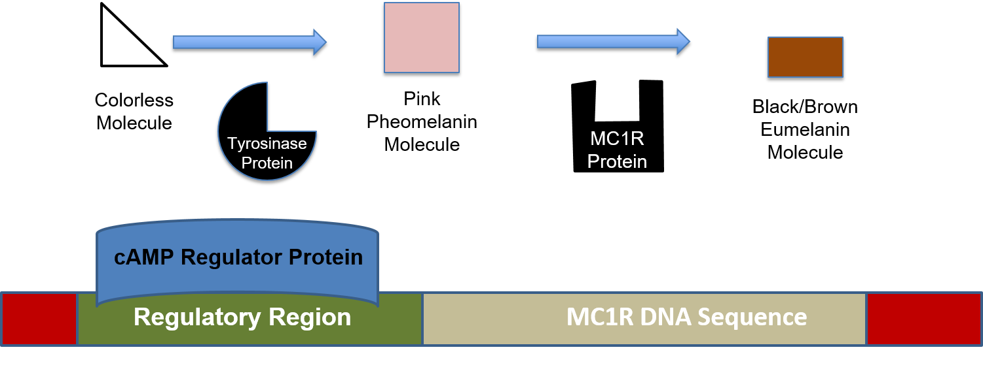
DNA | Protein | Trait in Humans
 |  | Albino
 |  | Light Skin Tone
 |  | Medium Skin Tone
 |  | Dark Skin Tone
What questions do you still have?

