AP Biology Biology Exploration Guide: Cell Communication #1
Negative and Positive Feedback
Human Endocrine System – Long Distance Signaling

Key Concepts:
- Animal form and function are correlated at all levels of organization
- Feedback loops maintain the internal environment in many animals
- Homeostatic processes for thermoregulation involve form, function, and behavior
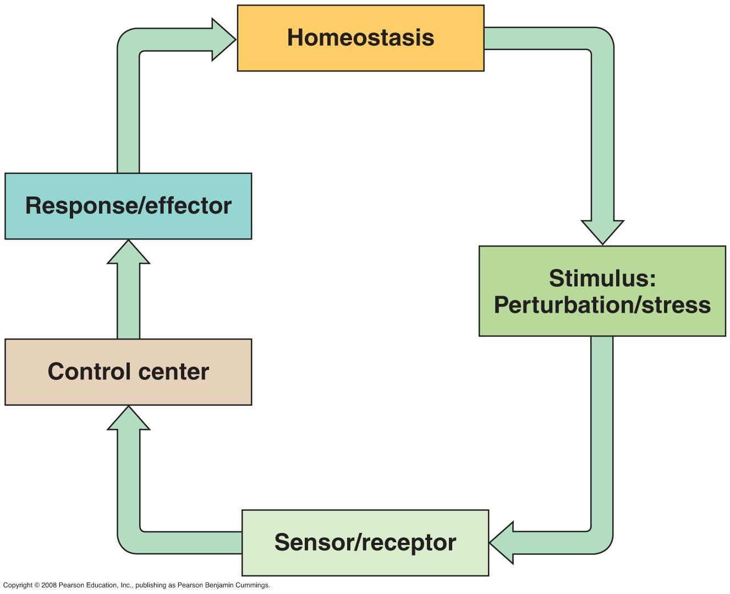
- Hormones and other signaling molecules bind to target receptors , triggering specific response pathways
- Negative feedback and antagonistic hormone pairs are common features of the endocrine system
- The endocrine and nervous systems act individually and together in regulating animal physiology
- Endocrine glands respond to diverse stimuli in regulating metabolism, homeostasis, development, and behavior

Read:
- Chapter 40
- Ch 44.5
- Chapter 45

Campbell Biology Online Tasks:
- MB (40, 44.5, 45, 48)

Key Terms: Here is a list of key terms and concepts you will hear about and see during the chapter readings. Get to know them!

Regulator | Homeostasis | Endothermic | Negative feedback
Conformer | Thermoregulation | Ectothermic | Positive feedback
Endocrine system | Autocrine | Thyroid gland | Oxytocin
Nervous system | Paracrine | T₃ / T₄ / thyroxine | Prolactin
Endocrine gland | Insulin / glucagon | PTH / Calcitonin | Estrogen / progesterone
Hormone | Hypothalamus | ADH / Aldosterone | Testosterone
Local regulators | Pituitary gland

Questions for Your BILL:
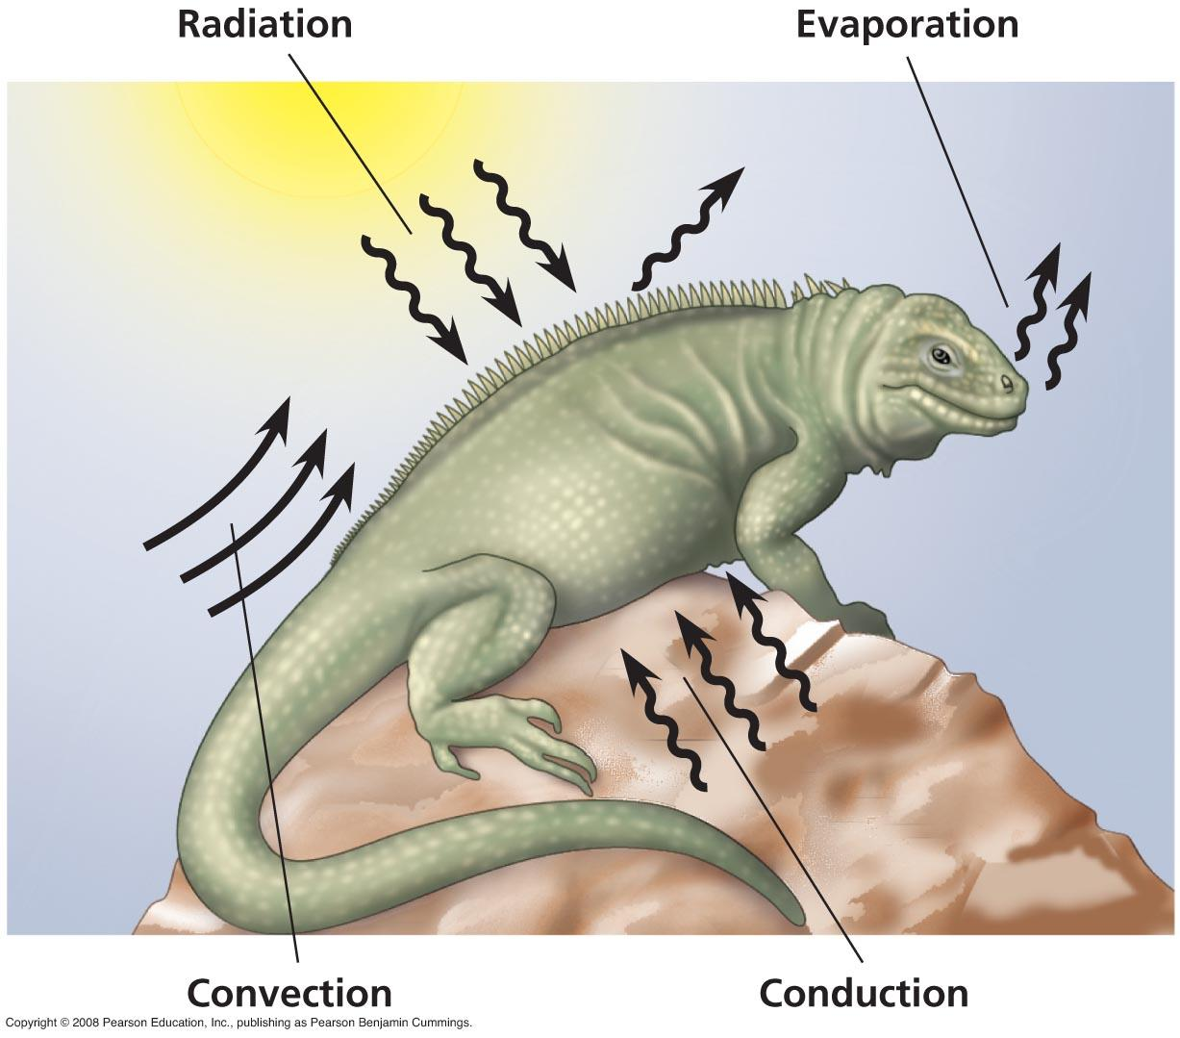
Regulating the Internal Environment (CH 40)
- Compare and contrast the nervous and endocrine systems with respect to specificity of target cells and speed and duration of response.
- Distinguish between regulators and conformers for a particular environmental variable. Explain how an animal may be both a regulator and a conformer.
- Define homeostasis. Describe in general terms how an animal maintains homeostasis.
- Distinguish between positive and negative feedback mechanisms. Which type of mechanism contributes to homeostasis?

Osmoregulation (Ch 44.5)
- How do hormonal circuits link kidney function, water balance and blood pressure.
- Describe how ADH manages the osmoregulatory function of the mammalian kidney.
- Explain the purpose of the renin-angiotensin-aldosterone system.
- How does the kidney maintain homeostasis?

Human Endocrine System (CH 45)
- Explain the purpose of each of the following modes of cellular communication in multicellular organisms, and give an example of each from human physiology. For each, identify the ligand, and the response:

- Cell-Cell contact.
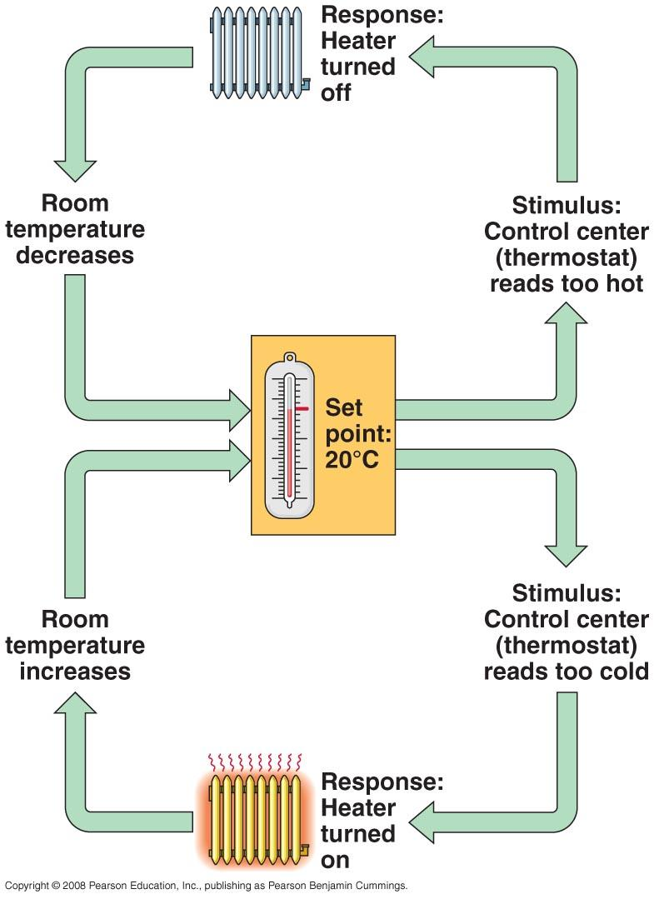
- Paracrine signalling
- Endocrine signalling
- Nervous system signaling.
- Define the following terms: endocrine glands, hormones.
- Compare and contrast lipid-based versus protein-based hormones. Provide a few examples of each.
- Distinguish between negative feedback control versus positive feedback control. Draw a diagram to illustrate and example of each type of feedback.
- Describe the relationship between the hypothalamus, pituitary gland, and the body’s endocrine glands
- Briefly explain the major glands, hormones and the effects of those hormones involved in each of the following aspects of human physiology. Create an drawing to illustrate your answer for each scenario:
  - Regulation of metabolism
  - Regulation of blood sugar levels
  - Regulation of blood osmolarity
  - Regulation of blood calcium levels
  - Regulation of the female menstrual cycle

Supplementary Resources: Click the links below for more information to help you learn more about this lesson.

Interactives

- Harvard Animation: Homeostasis
- WH Freeman Animation: Control, Regulation and Feedback
- McGraw Hill Animation: Positive and Negative Feedback
- WH Freeman Animation: Blood Glucose Regulation
- WH Freeman Animation: Blood Calcium Regulation
- Wiley Biology Animation: Hormones and Glucose Regulation

Lectures

- Bozeman Biology’s “The Endocrine System” video.
- Bozeman Biology’s “Homeostatic Loops” video.
- Crash Course Biology’s video: Great Glands - Your Endocrine System

