Biology Exploration Guide: Cell Communication #4
Plant Responses to Internal and External Signals

Key Concepts:
- Plant hormones help coordinate growth, development, and responses to stimuli
- Responses to light are critical for plant success
- Plants respond to a wide variety of stimuli other than light
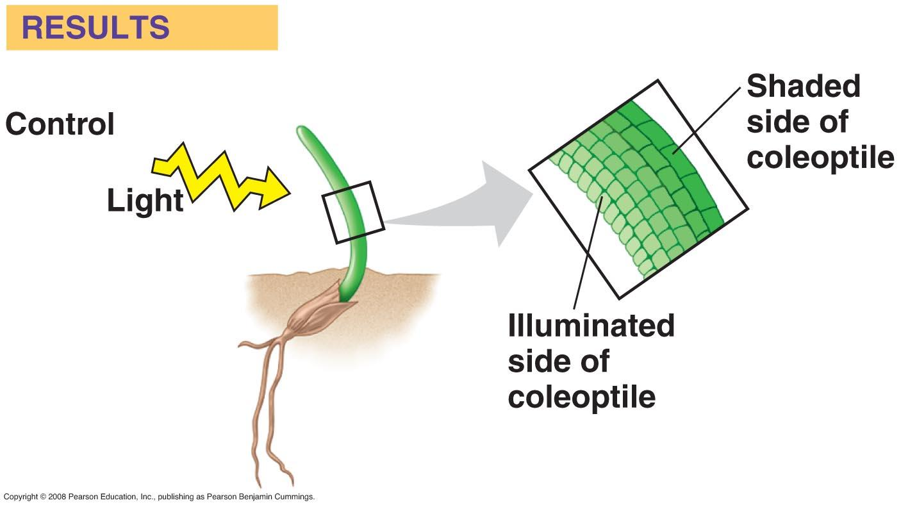
- Plants respond to attacks by herbivores and pathogens

Read:
- Chapter 39

Campbell Biology Online Tasks:
- MB 43,39

Key Terms: Here is a list of key terms and concepts you will hear about and see during the chapter readings. Get to know them!

Etiolation | Cytokinins | Leaf abscission | Long-day plant
De-etiolation | Gibberellins | Phytochromes | Day-neutral plant
Tropism | Ascisic acid (ABA) | Photoreceptors | Gravitropism
Phototropism | Ethylene | Photoperiodism | Thigmotropism
Auxins | Senescence | Short-day plant | Hypersensitive response
 |  |  | Systemic acquired resistance

Questions for Your BILL:

- Use a graphic organizer to describe the roles each of the following hormones plays in plants: auxins, gibberellins, cytokinins, ethylene, and abscisic acid (ABA).

- Create a diagram that explains how photoperiodism determines when flowering occurs.

- What is a tropism. Discuss the survival benefits of phototropism, gravitropism, and thigmotropism.

- Make a series of drawings to discuss several defense mechanisms developed by plants to protect themselves from herbivores and pathogens.

Supplementary Resources: Click the links below for more information to help you learn more about this lesson.

- WH Freeman Animation: Tropisms
- WH Freeman Animation: Photoperiodism
- McGraw Hill Animation: Phytochrome Signaling

