AP Biology Biology Exploration Guide: Molecular Genetics #1
DNA Structure and Replication
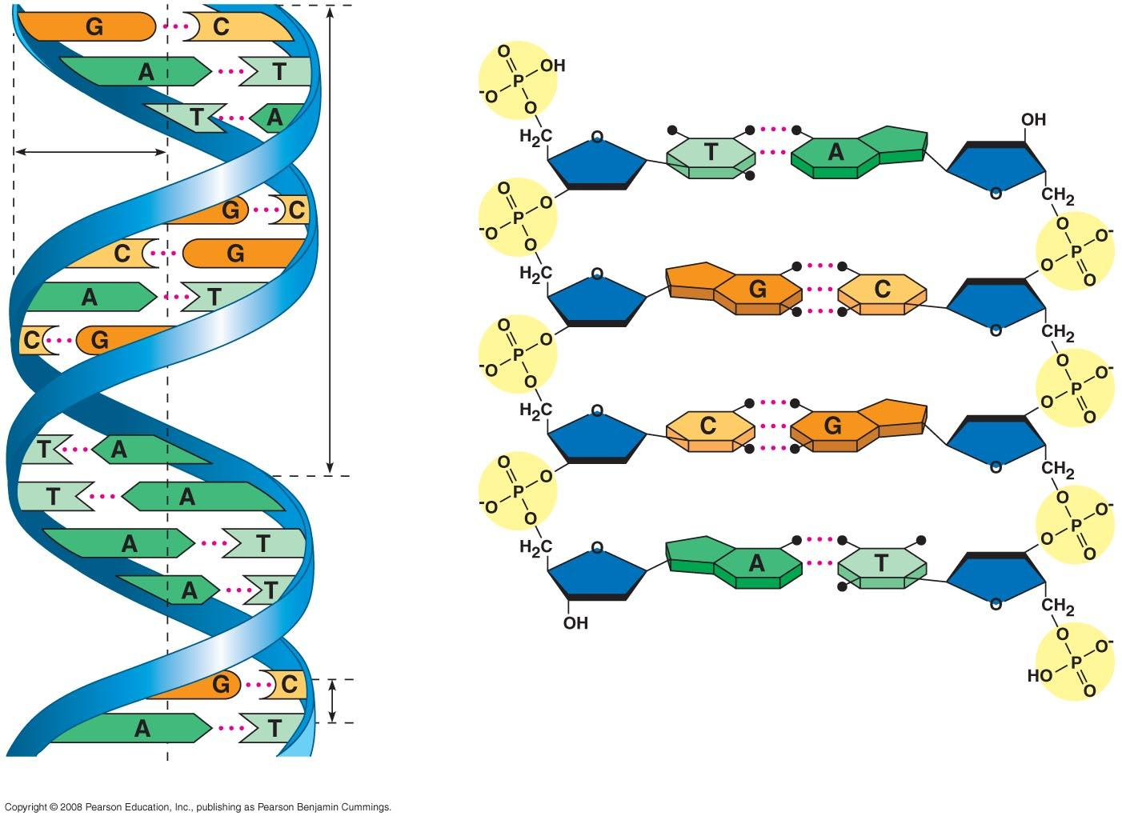
Key Concepts:
- DNA is the genetic material
- Many proteins work together in DNA replication and repair
- A chromosome consists of a DNA molecule packet together with proteins
- Understanding DNA structure and replication makes genetic engineering possible

Read:
- Chapter 16

Key Terms: Here is a list of key terms and concepts you will hear about and see during the chapter readings. Get to know them!

Frederick Griffith | James Watson | Guanine | DNA ligase
Transformation | Francis Crick | Semiconservative replication | Leading strand
Avery, McCarty, & MacLeod | Double helix | Replication bubble / fork | Lagging strand
Hershey & Chase | Deoxyribose | Helicase | Okazaki fragments
Erwin Chargraff | Adenine | Single-strand binding proteins (SSB) | Telomeres
Maurice Wilkins | Thymine | Primase | Telomerase
Rosalind Franklin | Cytosine | DNA polymerase I & III | Histones
 | Chromosome | Chromatin | Nucelosome

Questions for Your BILL:

DNA as the Genetic Material
- Explain why researchers originally thought protein was the genetic material.
- Explain how the experiments performed by the following scientists provided evidence that DNA is the genetic material:
  - Frederick Griffith
  - Oswald Avery, Maclyn McCarty, and Colin MacLeod
  - Alfred Hershey and Martha Chase
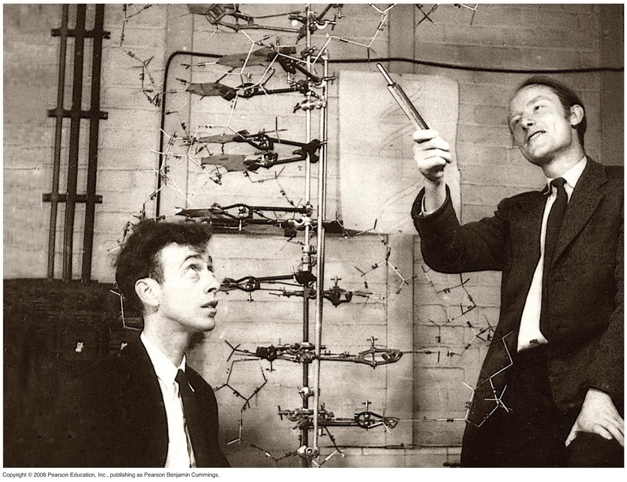
- A fly has the following percentages of nucleotides in its DNA: 27.3% A, 27.6% T, 22.5% G, and 22.5% C. How do these numbers demonstrate Chargaff’s rules?
- How did Watson and Crick’s model explain the basis for Chargaff’s rules?
- Explain how the work done by Rosalind Franklin and Maurice Wilkins helped inform Watson and Crick’s model of the structure of DNA.
- Based on Watson and Crick’s work, diagram the double helix structure of DNA. Include the following:
  - at least one A,T,C,G per strand
  - make sure to show the anti-parallel orientation of both strands
  - labels of 5’ to 3’, 3’ to 5’, deoxyribose sugar, phosphate, nitrogen bases (adenine, cytosine, guanine, and thymine), pyramidine, purine, covalent bonds, hydrogen bonds

DNA Replication and Repair
- Explain and/or diagram the experiment conducted by Meselson and Stahl. How did the results of their experiment demonstrate the semi-conservative model of DNA replication was the accurate model?
- Create a “cartoon strip” that illustrates the process of DNA replication. Add captions where it is necessary to clarify key points. Include the following information:
  - the role of the origins of replication and replication forks.
  - what energy source drives the polymerization of DNA.
  - distinguish between the leading strand and the lagging strand.
  - the roles of DNA ligase, DNA polymerases I and III, RNA primer, primase, helicase, Okazaki fragments, and single-strand binding proteins (SSB)..
- How does replication of the leading strand differ from replication of the lagging strand? Why can’t both strands of DNA be replicated in the same fashion?
- Explain the roles of DNA polymerase, mismatch repair enzymes, and nuclease in DNA proofreading and repair.
- Why are telomeres necessary during the replication of eukaryotic chromosomes?
- Explain the possible significance of telomerase in germ cells and cancerous cells.

Bacterial and Eukaryotic Chromosomes
- Make a drawing that compares a bacterial chromosome and a eukaryotic chromosome.
- Describe the structure of a nucleosome, the basic unit of DNA packing in eukaryotic cells.
- What two properties distinguish heterochromation and euchromatin?
- What are chromosomes and how does it differ from chromatin? During what part of the cell cycle are chromosomes formed? Why?

Supplementary Resources: Click the links below for more information to help you learn more about this lesson.

Interactives

- McGraw-Hill 3D Animation: DNA Replication 3D Animation
- Pearson’s BioCoach Activity: DNA Structure and Replication
- DNA From the Beginning: Molecules of Genetics
- Wiley Biology: DNA Replication Animation (the one used in class)
- Nobelprize.org: DNA – The Double Helix Game
- Nobelprize.org: The Nobel Prize in Physiology or Medicine 1962—Watson, Crick and Wilkins

Lectures

- TED Talk: James Watson – How I Discovered DNA
- Bozeman Biology’s “DNA & RNA Part 1” video.
- Bozeman Biology’s “DNA & RNA Part 2” video.
- Bozeman Biology’s “DNA Replication” video.
- Crash Course Biology’s video: DNA Structure & Replication
HYPERLINK "http://www.youtube.com/watch?v=8kK2zwjRV0M&list=PL3EED4C1D684D3ADF&index=10&feature=plpp_video"

