AP Biology Biology Exploration Guide: Molecular Genetics #2
Transcription and Translation
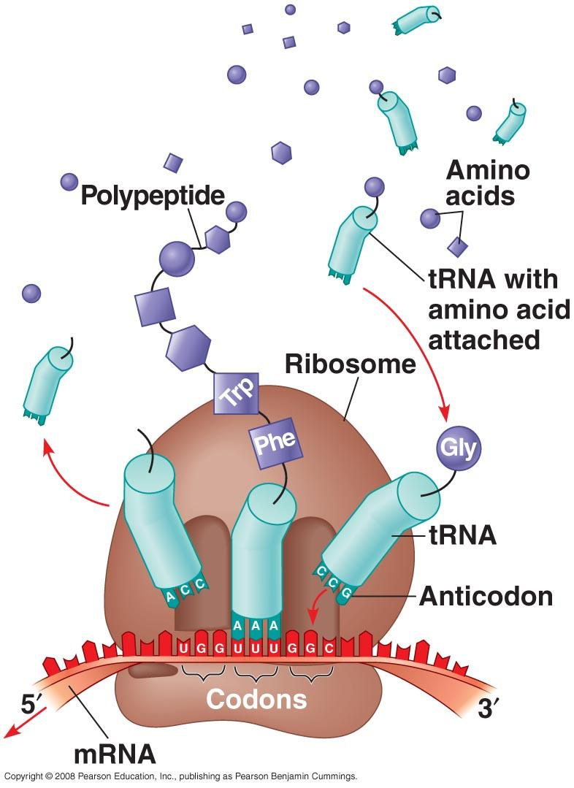
Key Concepts:
- Genes specify proteins via transcription and translation
- Transcription is the DNA-directed synthesis of RNA
- Eukaryotic cells modify RNA after transcription
- Translation is the RNA-directed synthesis of a polypeptide
- Point mutations can affect protein structure and function
- While gene expression differs among the domains of life, the concept of a gene is universal

Read:
- Chapter 17

Key Terms: Here is a list of key terms and concepts you will hear about and see during the chapter readings. Get to know them!

Gene expression | Reading frame | 5’ cap | Point mutation
Transcription | RNA polymerase | Poly-A tail | Base substitution
RNA processing | Promoter | Introns | Insertion
Translation | Terminator | Exons | Deletion
Messenger RNA (mRNA) | Intiation | Spliceosome | Frame shift
Transfer RNA (tRNA) | Elongation | snRNPs | Missense mutation
Ribosomal RNA (rRNA) | Termination | Alternative RNA splicing | Nonsense mutation
Ribosome | Transcription factors | P site (peptidyl-tRNA site) | Silent mutation
Codon | Transcription initiation complex | A site (aminoacyl-tRNA site) | Mutagen
Anticodon | TATA box | E site (exit site)

Questions for Your BILL:

The Connection between Genes and Proteins
- Define gene expression.
- Explain how the “one-gene-one protein” hypothesis was derived by Beadle and Tatum. Why has this hypothesis been refined to “one gene-one polypeptide,” and now “one gene-one (protein) domain?”
- Explain THREE structural ways in which RNA differs from DNA.
- Distinguish between the three types of RNA produced during transcription:
  - Messenger RNA (mRNA)
  - Transfer RNA (tRNA)
  - Ribosomal RNA (rRNA)
- Distinguish between transcription and translation.
- Compare where transcription and translation occur in bacteria and in eukaryotes.
- Francis Crick coined the term “central dogma” with regard to the relationship between DNA and RNA. Explain what Crick meant by this.
- Explain the relationship between protein synthesis and an organism’s phenotype.
- Define “codon” and explain the relationship between the linear sequence of codons on mRNA and the linear sequence of amino acids in a polypeptide.
- Explain the significance of the reading frame during translation.
- Explain the evolutionary significance of a nearly universal genetic code.

The Synthesis and Processing of RNA
- Create a cartoon strip that illustrates how RNA is modified after transcription in eukaryotic cells. Add captions to help highlight key points and terms. Include the following in your diagram:
- How does RNA polymerase identify where to begin transcription of a gene?
- Explain the relationship between the promoter, enhancers, and transcription factors.
- Diagram each of the following phases of transcription.
  - initiation
  - elongation
  - termination
- Create a cartoon strip that illustrates how RNA is modified after transcription in eukaryotic cells. Add captions to help highlight key points and terms. Include the following in your diagram:
  - RNA splicing
  - 5’ cap
  - poly-A tail
- Define and explain the role of ribozymes.
- Explain why, due to alternative RNA splicing, the number of different protein products an organism can produce is much greater than its number of genes.

The Synthesis of Protein
- Draw a tRNA molecule and discuss how its structure enables its function. Explain the significance of the anticodon and wobble in your tRNA molecule.
- Make a detailed diagram of a ribosome that illustrates the structures listed below. Describe the function of each component of the ribosome. Inlcude the following
  - small ribosomal subunit
  - large ribosomal subunit
  - P site, A site, and E site.
- Diagram the process of translation including the phases listed below and include the location (A, P, or E site) of incoming tRNA molecules, incoming amino acids, energy sources, the growing polypeptide chain, uncharged tRNA molecules and release factors as appropriate:
  - Initiation
  - Elongation
  - Termination
- Describe the significance of polyribosomes.
- Explain the purpose of a signal peptide at the beginning of a newly synthesized protein.
- Use the following DNA nucleotide sequence to create the appropriate codon sequence for a strand of mRNA, the appropriate series of tRNA anticodons, and ultimately the amino acid sequence that would be generated.
(DNA template strand) T-A-C-T-C-A-G-T-G-G-G-G-C-A-C-T-T-A

Point Mutations
- Define “point mutations”.
- Distinguish between the following types of mutations:
  - Silent mutation
  - Missense mutation
  - Nonsense mutation
  - Frameshift mutation
- Why is an insertion or deletion more likely to be deleterious than a substitution?
- Define the term ‘mutation’. Give an example of a physical and a chemical agent of mutation.

Supplementary Resources: Click the links below for more information to help you learn more about this lesson.

Interactives

- McGraw-Hill 3D Animation: Molecular Biology of the Gene (Protein Synthesis)
- Pearson’s BioCoach Activity: Transcription and Translation
- University of Utah Genetic Science Learning Center: DNA to Protein
- McGraw Hill: Transcription Animation
- McGraw Hill: RNA Processing
- McGraw Hill: Translation Animation
- University of Nebraska: Transcription Animation
- University of Nebraska: Translation Animation

Lectures

- Bozeman Biology’s “Transcription & Translation” video.
- Bozeman Biology’s “The Central Dogma” video.
- Bozeman Biology’s “Genotypes and Phenotypes” video.
- Crash Course Biology’s video: DNA, Hot Pockets, & The Longest Word Ever
- Crash Course Biology: DNA Transcription and Translation
HYPERLINK "http://quietube5.com/v.php/http://www.youtube.com/watch?v=itsb2SqR-R0"

