AP Biology Biology Exploration Guide: Molecular Genetics #3
Regulation of Gene Expression
Key concepts:
- Bacteria often respond to environmental change by regulating transcription
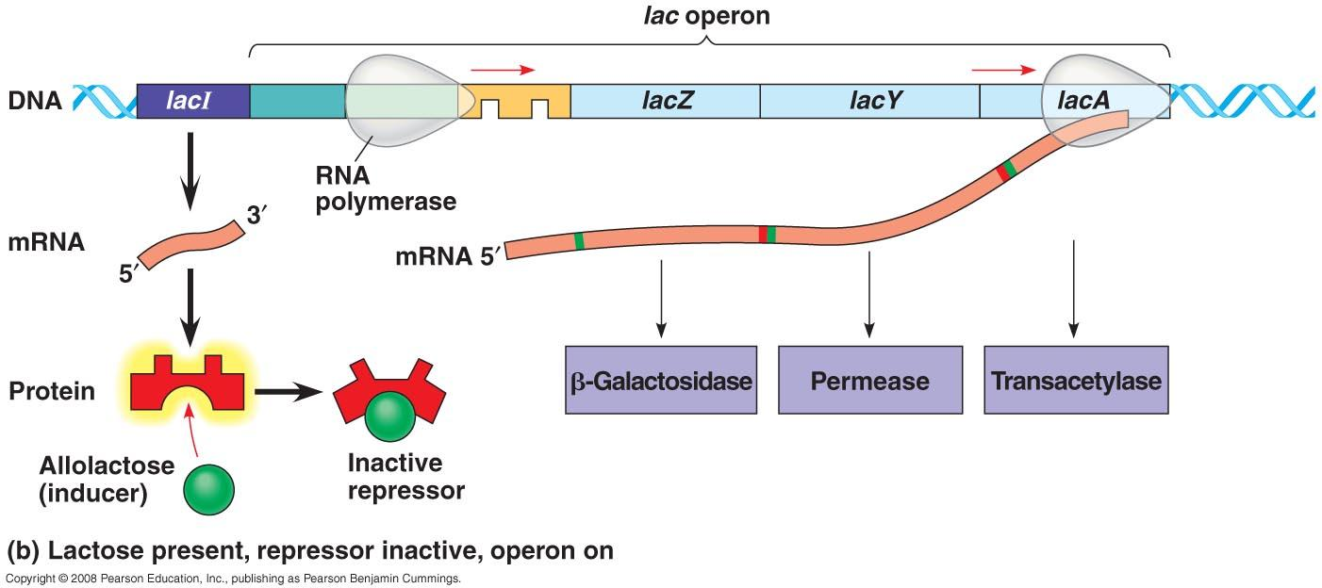
- Eukaryotic gene expression can be regulated at any stage
- Noncoding RNAs play multiple roles in controlling gene expression
- A program of differential gene expression leads to the different cell types in a multicellular organism
- Viruses consist of a nucleic acid surrounded by a protein coat
- Viruses replicate only in host cells
- Rapid reproduction, mutation, and genetic recombination promote genetic diversity in prokaryotes

Read:
- Chapter 18.1-18.4 (pp. 351-377)
- Chapter 19.1-2 (pp.381-390)
- Chapter 27.2 (pp.576-579)

Key Terms: Here is a list of key terms and concepts you will hear about and see during the chapter readings. Get to know them!

Operon | Methylation | microRNAs (miRNA) | Pattern formation
Operator | Histone acetylation | RNA interference (RNAi) | Positional information
Repressor | Genomic imprinting | Small interfering RNAs (siRNAs) | Homeotic genes
Regulatory gene | Epigenetics inheritance | Ubiquitin | HOX genes
Corepressor | Enhancers | Proteasomes | Maternal effect gene
Inducer | DNA bending protein | Cell differentiation | Morphogens
Activator | Mediator proteins | Morphogenesis | Capsids
Differential gene expression | mRNA degradation | Cytoplasmic determinants | Bacteriophages
Host range | Lytic cycle | Lysogenic cycle | Prophage
Transformation | Transduction | Conjugation | F plasmid and R plasmid

Questions for Your BILL:

Regulation of Prokaryotic Gene Expression
Prokaryotes do not undergo development and become multicellular organisms, so these cells do not differentiate (turning some genes on and some genes off). However they do use gene controls. By adjusting gene expression, they can respond to environmental conditions. Prokaryotes control their gene expression mainly by adjusting the rate of transcription.

- Define operon.
- What is the advantage to prokaryotes grouping related metabolic gene products into a single operon?
- An operon contains the following components: promoter, operator, structural gene, and regulatory gene. Explain how each component contributes to the functioning of the operon.
- Discuss the role of repressor proteins and activator proteins in operons.
- Make a drawing(s) with captions and use the example of the lac operon in E. coli bacteria to explain how an inducible operon works.
- Make a drawing(s) with captions and use the example of the trp operon in E. coli bacteria to explain how a repressible operon works.
- Compare a repressible operon with an inducible operon. How are they similar? How are they different? What determines if an operon will be repressible or inducible? Give an example of each type of operon in a typical prokaryotic cell.

Regulation of Eukaryotic Gene Expression
When eukaryotic cells differentiate or specialize they begin to express different subsets of genes. A cell rarely uses more than 10% of its genes at once. So how does a cell express some genes and “turn off” other genes?

- Why do eukaryotic cells need to be able to turn genes on and off as necessary?
- Define each of the following terms and explain how each provides a eukaryotic cell with the ability to regulate gene expression:
- Histone acetylation
- DNA methylation
- Transcription factors/enhancers
- alternative splicing
- mRNA degradation
- RNA interference (RNAi)
- Protein processing and degradation

EPIGENETICS

The Cellular and Molecular Basis of Differentiation and Morphogenesis in Animals
- The remarkable transformation from a zygote to the organism it becomes results from three interrelated processes: cell division, differentiation, and morphogenesis. Distinguish between differentiation and morphogenesis.
- Almost all cells in an organism have the same genome; explain what makes cells different from each other.

Differentiation
- Define determination. Discuss what a determined cell can and cannot do.
- Cytoplasmic (maternal) determinants are RNA and protein molecules encoded from the mother’s DNA and passed on to the zygote. Explain how cytoplasmic determinants and the unequal distribution of cytoplasm during cell division influences cell differentiation.
- Use a diagram to explain how embryonic induction influences the differentiation of cells in early development.
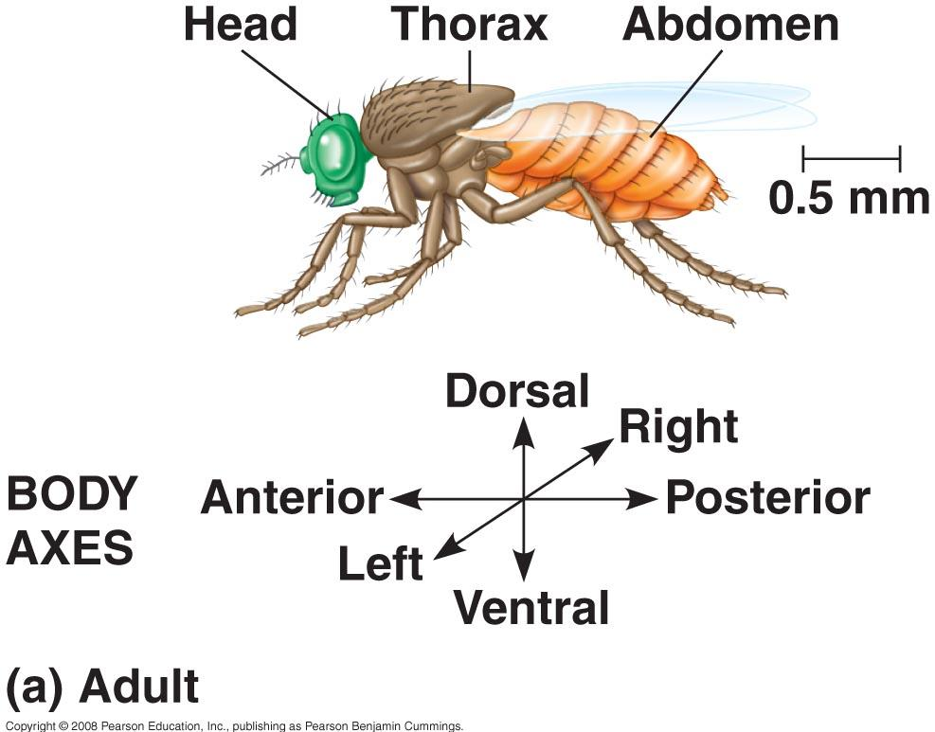
Pattern Formation & Morphogenesis
- Define pattern formation.
- Cytoplasmic determinants and inductive signals are also involved in determining a cell’s positional information. Discuss the importance of positional information in pattern formation.
- Describe the role of homeotic genes (also called selector genes or in mammals they are called Hox genes).
- Compare the order of homeotic genes on a chromosome to the order of body structures they code for.
- Explain how knockout experiments are used to identify homeotic genes.
- Discuss what can be concluded form the fact that many homeotic genes can work across different species.
- Distinguish between maternal effects genes and morphogens.

Viruses

- What are the components of a virus?
- Discuss the differences between lytic and lysogenic cycles
- How do viruses introduce genetic variation into host organisms?

Genetic Diversity in Prokaryotes

- What is horizontal gene transfer?
- Describe the three mechanisms by which bacteria can transfer genetic material between each other.

Supplementary Resources: Click the links below for more information to help you learn more about this lesson.

Interactives

- Pearson’s BioCoach Activity: The lac operon in E.Coli
- McGraw-Hill Animation: The Tryptophan Repressor
- McGraw-Hill Animation: The Lac Operon
- McGraw-Hill Animation: The Lac Operon #2
- Hillis: Animated lac operon
- Hillis: Animated trp operon
- Hillis: Eukaryotic Gene Expression Control Points Activity
- Scitable by Nature: Hox Genes in Development
- Berkeley Evolution: Hox Genes
- WH Freeman Animation: Pattern Formation
- DNA Learning Center: Master genes control basic body plans
- Nobelprize.org: The Nobel Prize in Physiology or Medicine 1965—Jacob, Lwoff and Monod (operons)

Lectures

- Bozeman Biology’s “Gene Regulation” video.

