Biology Exploration Guide: Molecular Genetics #4
Biotechnology

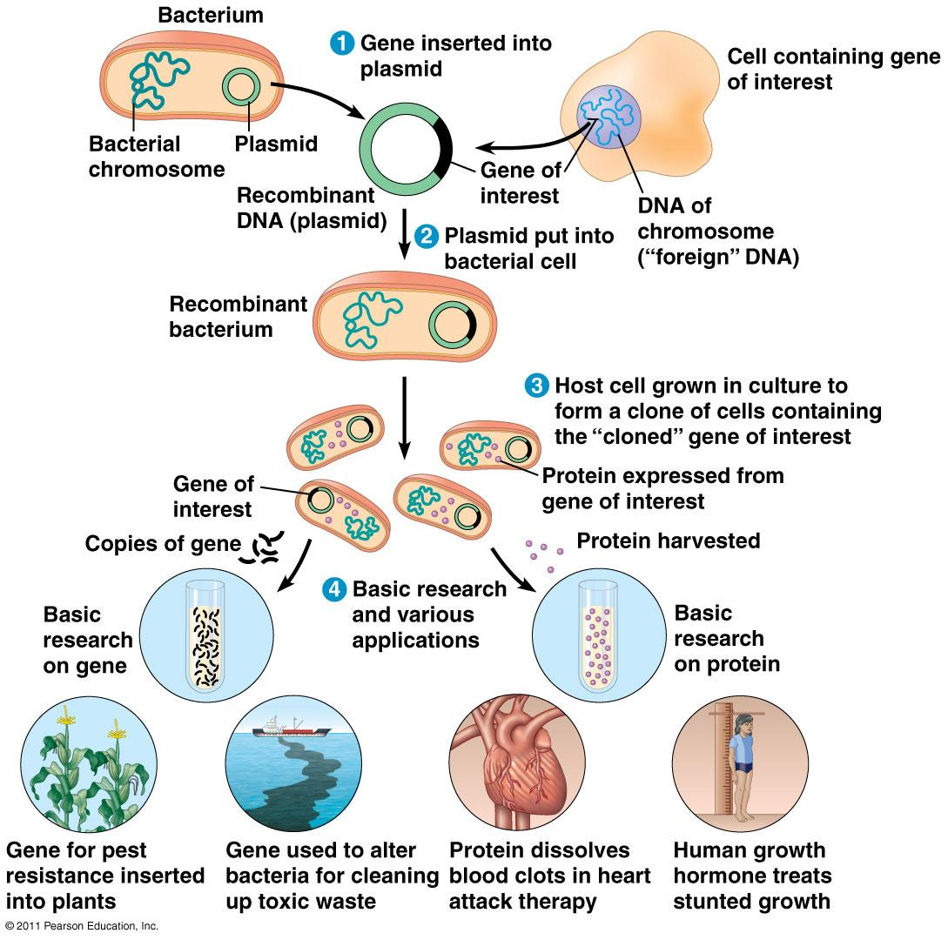
To Think About:
- DNA cloning yields multiple copies of a gene or other DNA segment
- DNA technology allows us to study the sequence, expression, and function of a gene
- The practical applications of DNA technology affect our lives in many ways
- The potential benefits and concerns of developing transgenic and genetically modified organisms for human purposes
- DNA cloning yields multiple copies of a gene or other DNA segment
- DNA technology allows us to study the sequence, expression, and function of a gene
- The practical applications of DNA technology affect our lives in many ways
- The potential benefits and concerns of developing transgenic and genetically modified organisms for human purposes

Read:
- Chapter 20

Key Terms: Here is a list of key terms and concepts you will hear about and see during the chapter readings. Get to know them!

Biotechnology | Plasmids | Knock out genes | Ex vivo / In vivo
Recombinant DNA | Transformation / Transgenic | Cloning | Gentically Modified Organism (GMO)
Genetic Engineering | Genomic library | Nuclear transplantation
DNA cloning | Polymerase chain reaction (PCR) | Restriction fragment length polymorphism (RFLP) | Genetic profile
Restriction enzymes | Gel electrophoresis |  | Short tandem repeats (STR)
Restriction site | Southern Blotting | Single nucleotide polymorphism (SNP) | Genomics
Sticky ends | DNA sequencing |  | Proteomics
Vector | DNA microarray | Gene therapy | Bioinformatics

Questions for Your BILL:

Recombinant DNA Technology
- Define the follow terminology: biotechnology, genetic engineering, recombinant DNA, gene cloning,
- Describe the natural function of restriction enzymes and explain how they are used in recombinant DNA technology.
- Using a drawing to explain how the creation of sticky ends on the restriction fragments by restriction enzymes is useful in producing a recombinant DNA molecule.
- Make a cartoon strip that outlines and explains step-by-step the procedures for engineering and cloning a eukaryotic gene (such as human insulin or human growth hormone) in a bacterial plasmid.
- Explain the rationale for including a gene for antibiotic resistance and a gene that codes for a hydrolytic enzyme (such as PGAL or arbinose in pGLO) in the plasmid.

- Explain the purpose of the polymerase chain reaction (PCR). Why is it useful?
- Explain the function of the following in PCR
- Taq polymerase
- primers.
- thermal cycler.
- Explain what happens during each phase of a PCR cycle, and the temperature at which each phase occurs:
- Denaturation.
- Annealing.
- Elongation.
- Create a cartoon strip that outlines and explains step-by-step how to run a gel electrophoresis to analyze a series of DNA samples.
- Where will the smallest fragments of DNA be found on a gel after it runs? Where will the largest fragments be found? How is the size of a particular fragment determined?

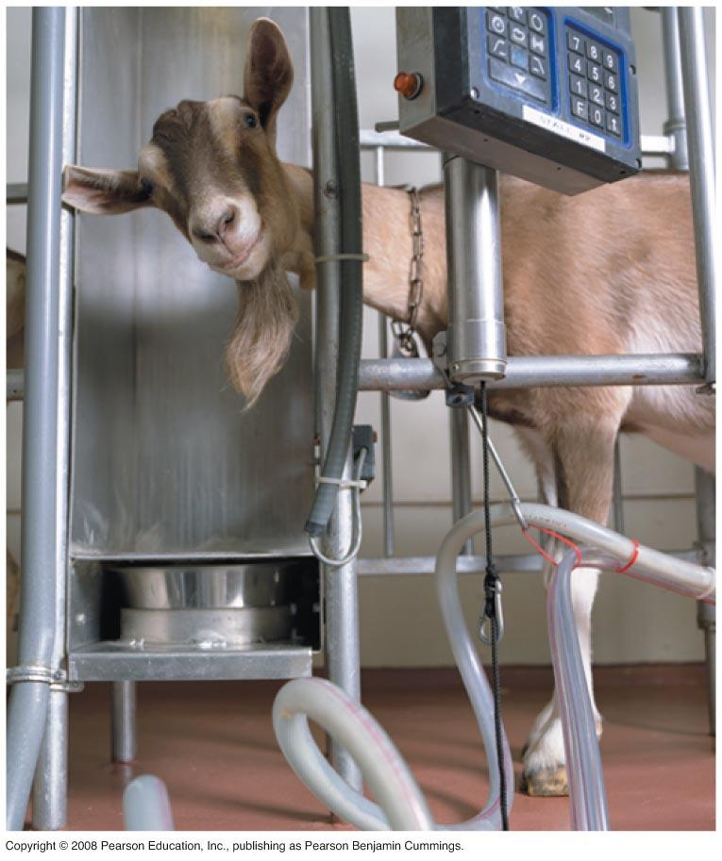
Biotechnology Products

- Distinguish between a transgenic animal and a cloned animal.
- Create a series of drawings and use your drawings to describe how nuclear transplantation was used to produce Dolly, the first cloned sheep.
- Explain why cloned animals are so likely to have defects.
- Distinguish between reproductive cloning and therapeutic cloning.
- What is pharming, how is it done, and what are its advantages over more conventional biotechnology approaches?
- Create a t-chart that lists the benefits and drawbacks to genetic modification of organisms.

Gene Therapy

- Describe the methods that are being used to introduce genes in human beings for gene therapy.
- Discuss and example of ex vivo and of in vivo gene therapy.

Genomics
- Distinguish between the genome and the proteome of a cell.
- What was the purpose of the Human Genome Project? What is the goal of functional genomics.
- Summarize the difference between a short tandem repeat and a transposon.
- How does short tandem repeats (STR) profiling produce a DNA fingerprint?
- What is the purpose of a DNA “library”? How can specific genes be retrieved from a DNA library?
- What are the differences between a genomic library and cDNA library?
- Explain why we would want to determine the base sequence of a piece of DNA.
- What are dideoxynucleotides? Why are they used in DNA sequencing?
- Explain how the Sanger sequencing method works.
- How has sequencing technology advanced since the development of the process by Fred Sanger? Give three examples.
- Explain the relationship between single nucleotide polymorphisms (“SNPs”) and restriction fragment length polymorphisms (“RFLPs”)? How are they caused and why do they matter?
- Outline the steps involved in “knocking out” a gene in a bacterium and in an animal. What are the uses for these methods?
- What is the purpose of a microarray? Give an example of a real-world application of microarray analysis.
- Explain how the use of microarrays and bioinformatics aids in the study of genomics and proteomics.
- What are the goals of proteomics and bioinformatics?
- Give three examples of things that the biotechnology revolution has allowed us to do that couldn’t have been done at a prior point in human history.

You will most likely need to do a bit of research to answer these questions:
- From a legal standpoint, how much information do you have a right to know about the genetically engineered nature of the food you eat and the products that you consume?
- From a legal standpoint, how much information do other people and entities have the right to know about your genome?
- From a legal standpoint, what sorts of genetically engineered technologies are individuals allowed to copyright?
- From a legal standpoint, what constraints are placed on the scientific establishment with regard to altering the genetic material of organisms?

This one is for your own consideration:
- Consider the answers to the last five questions. From a personal moral/ethical standpoint, how do you feel about those answers?

Supplementary Resources: Click the links below for more information to help you learn more about this lesson.

Interactives

- Pearson’s BioCoach Activity: Restriction Enzyme Digestion of DNA
- Utah Learn Genetics: Virtual Lab – Gel Electrophoresis
- Utah Learn Genetics: Virtual Lab – Polymerase Chain Reaction (PCR)
- Utah Learn Genetics: Transgenic Mice
- Utah Learn Genetics: Gene Therapy
- Utah Learn Genetics: Cloning
- DNA Learning Center Online Lab: Bacterial Transformation
- DNA Learning Center Online Lab: DNA Fingerprinting
- DNA Learning Center Online Lab: Restriction Analysis
- NCBI (National Center for Biotechnology Information)
- Utah Learn Genetics: Virtual Lab – DNA Microarray
- Scitable by Nature: Genomics
- National Genome Research Institute – Human Genome Project
- National Genome Research Institute – Home Genome Project – In Depth
- National Center for Biotechnology Information (NCBI) – Bioinformatics Fact Sheet
- National Center for Biotechnology Information (NCBI) – Genome Mapping Fact Sheet
- National Center for Biotechnology Information (NCBI) – SNPs
- Sumanas, Inc. Animation – Creating a DNA Library
- DNA Learning Center – Knockout Genes

Lectures

- Bozeman Biology’s “Molecular Biology” video.

