Name: ______________________________________________ Explaining functions that all plants share

1. All plants make glucose. How do their cells do that? Explain in words, and draw a model of what occurs.

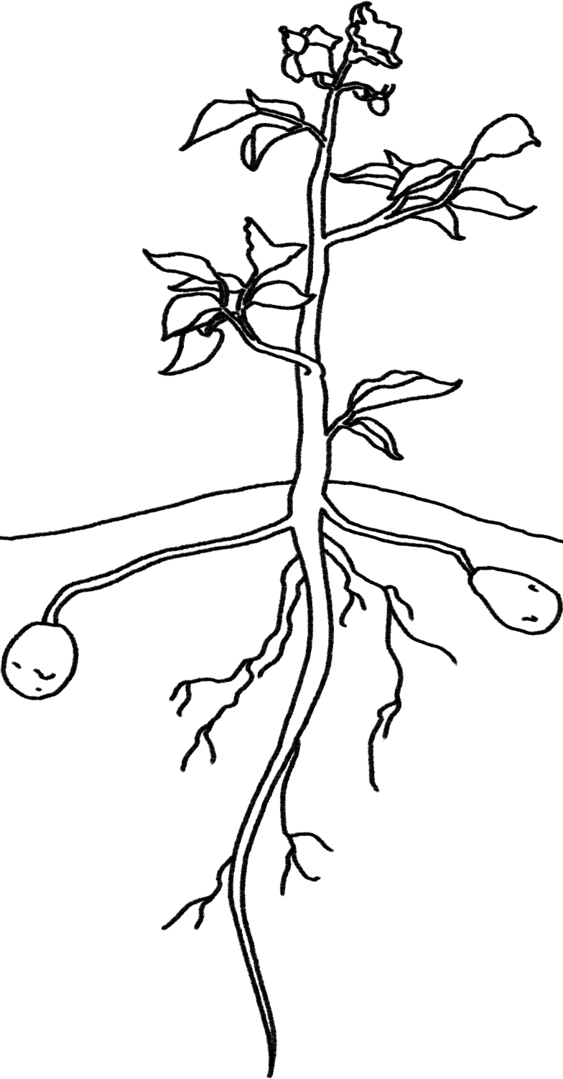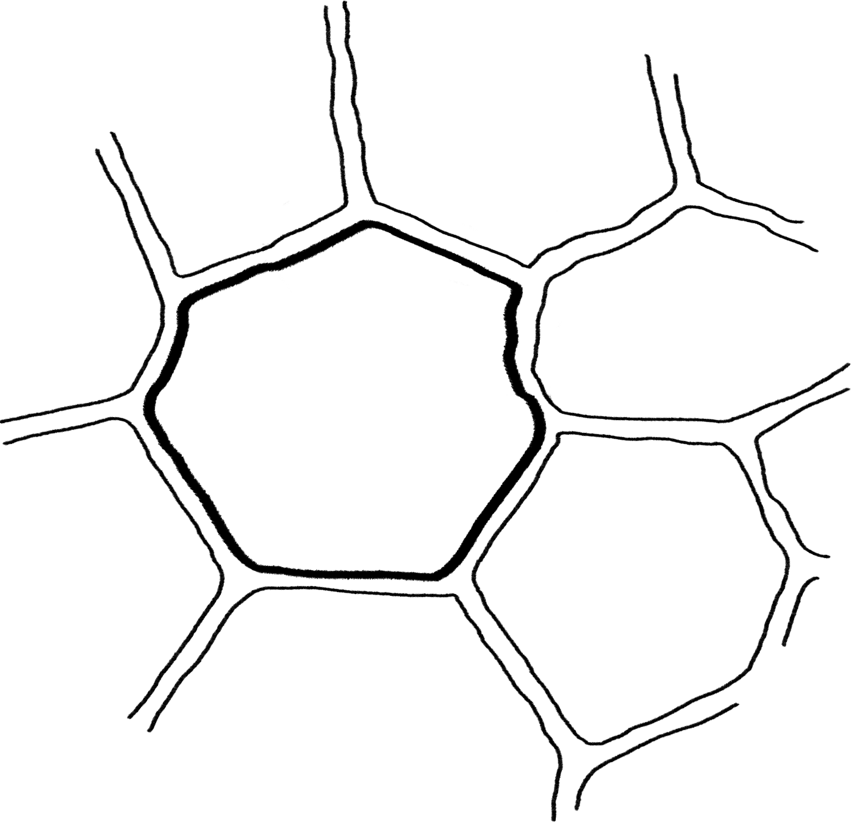

2. All plants use energy to move and function. How do their cells do that? Explain in words, and draw a model of what occurs.

3. All plants grow. How do their cells do that? Explain in words, and draw a model of what occurs.

