**Exploring Environmental Effects on the Cell Cycle**

**Introduction**: The environment has substantial effects on the process of cellular division. Mitosis, one type of cell division, is the process by which a eukaryotic cell separates the chromosomes in its cell nucleus into two identical sets, in two separate nuclei. With environmental factors, such as rainfall or lectin protein, mitosis is induced in some root apical meristem tissues. Lectin is a protein found in soil near roots, which stimulates the rapid division of cells.

In this activity, you will determine the effect that lectin has on the cell cycle rate of onion root tips.

**Procedure**:

1. Obtain a microscope and a slide of an onion root tip. You may need to clean the slide by wiping it with a piece of lens paper (NOT a paper towel).
2. Scan the slide under low power first and locate the apical meristem, the region of rapidly dividing cells directly behind the protective root cap. Refer to the following Figures for guidance.



1. Switch to medium power and center your slide in the apical meristem region, so that you have a field of view which there is a wide selection of cells in both interphase and mitosis.
2. Switch to high power and refocus.
3. Identify the stage of each cell in your field of view as either interphase or mitosis. Count your cells in a systematic manner (such as starting in the top right corner and moving across the field of view like reading a paragraph). Record in Data Table 1
4. Move your slide to a new root tip and perform a second count. Record your data.
5. Repeat a third time using another root tip. Record your data. **You must count a minimum of 300 cells**
6. Now, sum across the count areas to find the total number of cells in each stage.

**Data Table 1**. Onion Root Tip Cell Phase Data; CONTROL

|  |  |  |  |
| --- | --- | --- | --- |
|  | **NUMBER OF CELLS** | | |
| **Onion Tip** | **Interphase** | **Mitotic** | **Total** |
| 1 |  |  |  |
| 2 |  |  |  |
| 3 |  |  |  |
| Total |  |  |  |

1. The following table represents the data that was collected from three onion root tips that were treated with lectin.

**Data Table 2**. Onion Root Tip Cell Phase Data; LECTIN-TREATED

|  |  |  |  |
| --- | --- | --- | --- |
|  | **NUMBER OF CELLS** | | |
| **Onion Tip** | **Interphase** | **Mitotic** | **Total** |
| 1 | 130 | 66 | 196 |
| 2 | 142 | 63 | 205 |
| 3 | 103 | 41 | 144 |
| Total | 375 | 170 | 545 |

1. Complete data tables 3 and 4 after you have compiled numbers from the other groups in the class.

**Data Table 3**. CLASS DATA

|  |  |  |  |
| --- | --- | --- | --- |
| **GROUP** | **NUMBER OF CELLS** | | |
|  | **Interphase** | **Mitotic** | **Total** |
| Control |  |  |  |
| Treated | 2250 | 1018 | 3268 |

**Data Table 4**. Percentage of Cells in Each Phase (Class Data)

|  |  |  |
| --- | --- | --- |
| **GROUP** | **% OF CELLS** | |
|  | **Interphase** | **Mitotic** |
| Control |  |  |
| Treated |  |  |

**Chi-square Analysis:**

Conduct a chi-square test to determine if lectin truly did have an effect on the rate of cell division in the root plants.

* Null hypothesis:
* **Observed** number of treated cells in interphase (from class data) =
* **Expected** number treated cells in interphase (from class data)=
  + Expected = (% of *control* cells in interphase ) × (total number of cells in the *treated* group)
* **Observed** number of treated cells in mitosis (from class data) =
* **Expected** number treated cells in mitosis (from class data)=
  + Expected = (% of *control* cells in mitosis ) × (total number of cells in the *treated* group)
* 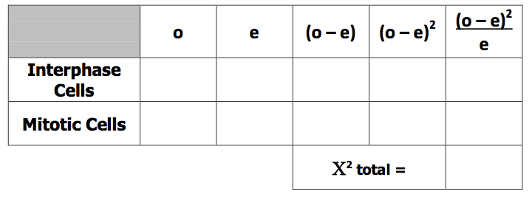Calculations:
* Chi-square value:
* Degrees of freedom:
* Critical value:
* Conclusion:

**Analysis Questions:**

1. What are MPFs, Cdks and cyclins? What is the relationship among these molecules in controlling the cell cycle?
2. Can a cell that is normally non-dividing be stimulated to divide? When does this happen and how is it accomplished in an organism?
3. Cancer cells do not *respect their neighbors.* Describe what this means in more technical terminology. How is this different than normal cell functioning?

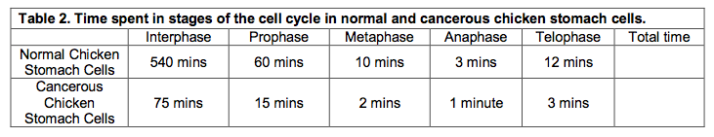Review the data below and answer the questions that follow.

1. Determine the time of the cell cycle for both normal and cancerous cells. How does it differ?
2. What percent of time does a normal cell spend in interphase?
3. What percent of time does a cancerous cell spend in interphase?