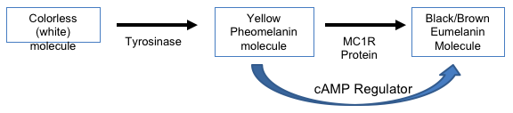
Skin color is determined by two genes – TYR and MC1R. The amount of MC1R produced is determined by the regulator protein cAMP. The more cAMP, the more MC1R produced and the more eumelanin produced resulting in darker skin pigment.

Important Information: Assume the MC1R and cAMP gene are both located on chromosome 16. For purposes of this case, assume all individuals have a functional tyrosinase.
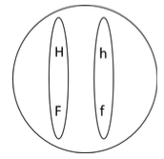
The MC1R gene has two versions:
H = functional h = non-functional

The cAMP gene has two versions:
F = functional f = non-functional

The dad is heterozygous for both genes (both dominant on one chromosome) and mom is homozygous dominant for MC1R and has one functioning copy of the cAMP gene, the other is non-functioning.

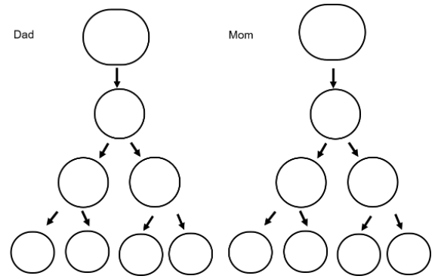
Complete the model of what the genetic possibilities will be! Assume that crossing over will happen one time in Dad.

What are all possible outcomes of fertilization between mom and dad?

What would mom and dad’s cells look like after mitosis?

