Must-Knows: Unit 4 (Cellular Respiration)
Mrs. Wilkening, AP Biology

Directions: To prepare for your upcoming test, please answer the following questions thoroughly and accurately on your answer sheet in the column titled “Your Answer Before Checking the Answer Key.”
Objective #2: You will be able to describe the role of glycolysis, the formation of Acetyl CoA, and the Krebs Cycle in cellular respiration.

- What evidence do scientists have to indicate that glycolysis is an ancient process?

- What are the reactants (starting molecules) and products (ending molecules) of glycolysis?

- Describe the amount and type of ATP production during glycolysis. (Note: The type of ATP production refers to substrate-level phosphorylation vs. oxidative phosphorylation.)

- What are the reactants (starting molecules) and products (ending molecules) of the intermediate step between glycolysis and the Krebs / citric acid cycle in which pyruvate is converted to Acetyl CoA?

- What are the reactants (starting molecules) and products (ending molecules) of the Krebs / citric acid cycle?

- After the Krebs cycle, how is most of the energy from the original glucose molecule stored?

Objective #3: You will be able to describe the role of the electron transport chain and chemiosmosis in the formation of ATP and list the steps involved in these processes.

- How are high-energy electrons from NADH and FADH2 used during the electron transport chain?

- How is oxygen gas (O₂) used during the electron transport chain?

- Why are their folds (aka cristae) in the inner mitochondrial membrane?

- Define “proton motive force.” How is this used during the electron transport chain?

- How is oxidative phosphorylation / chemiosmosis (the type of ATP production that occurs in the electron transport chain) different from substrate-level phosphorylation? Is there more or less ATP made during oxidative phosphorylation than substrate-level phosphorylation?

Objective #4: You will be able to describe the use of anaerobic respiration in living organisms.

- How is aerobic respiration different from anaerobic respiration (aka fermentation)? Which steps of aerobic respiration (i.e. glycolysis, the conversion of pyruvate to acetyl CoA, the Krebs cycle, or the electron transport chain) occur during anaerobic respiration?

- Why does NAD+ need to be regenerated from NADH for glycolysis to continue? How is this accomplished in lactic acid fermentation vs. alcoholic fermentation?

- In what types of organisms / cells does each type of fermentation occur?
Science Skills: You will be able to design an effective experiment and analyze data.

An experiment to measure the rate of respiration in crickets and mice at 10°C and 25°C was performed using a
respirometer, an apparatus that measures changes in gas volume. Respiration was measured in mL of O2
consumed per gram of organism over several five-minute trials and the following data were obtained.

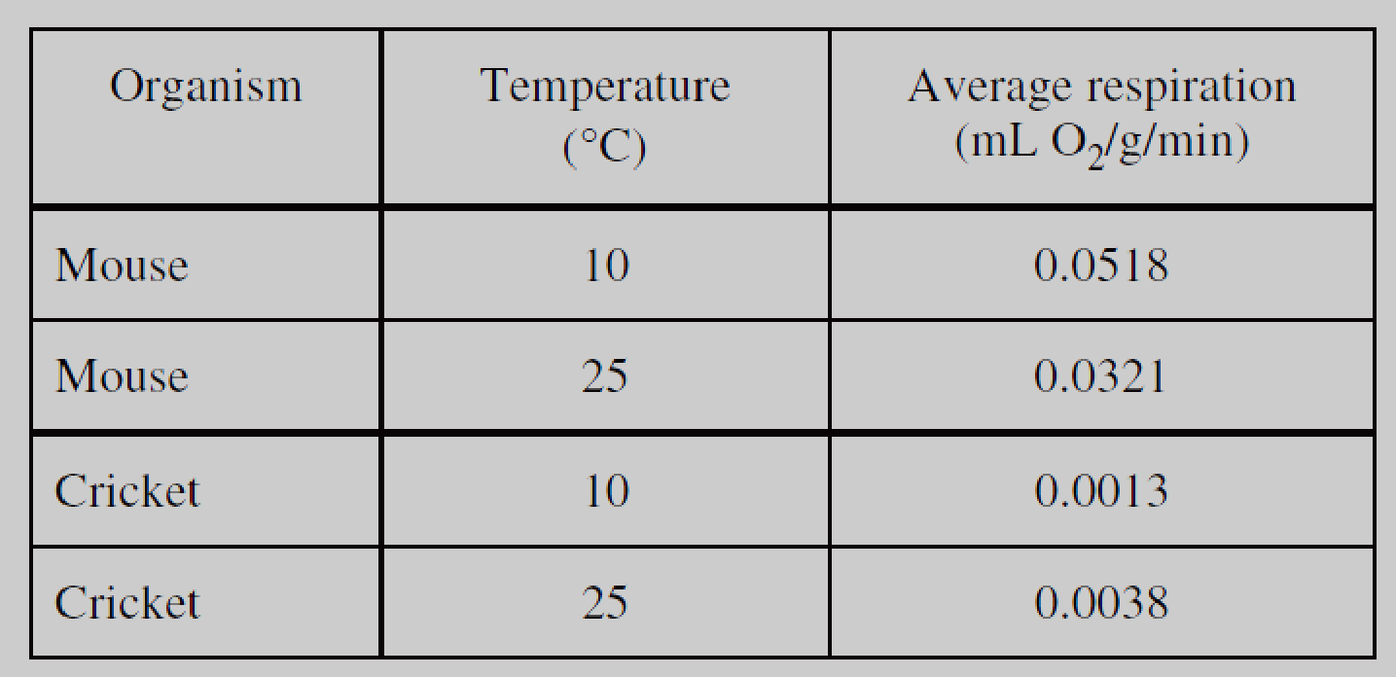
- How will carbon dioxide produced by the crickets and mice affect the measurements of average respiration (mL O₂ / g / min)? How did we address this issue in our respirometer lab?

- Why do you think the rate of respiration is higher at lower temperatures for both crickets and mice?

- If mice are endotherms (regulate their temperature by using the energy from ATP to generate body heat) and crickets are ectotherms (regulate their temperature using behaviors like basking in the sun), how do you explain the difference in rate of respiration for mice vs. crickets at both 10 degrees Celsius and 25 degrees Celsius?

A respirometer is a container used to measure the amount of oxygen consumed by an organism. A respirometer was used to determine how environmental temperature affects the uptake of oxygen in one 300-gram rat and one 50-gram mouse. The results of this experiment are shown on the graph below.

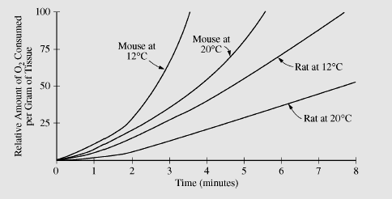

- From the data given above, what can you conclude about the effect of temperature and body mass on the rate of cellular respiration?

