Name ________________________________________ Date ______________ Hour _____

See – Think – Suggest

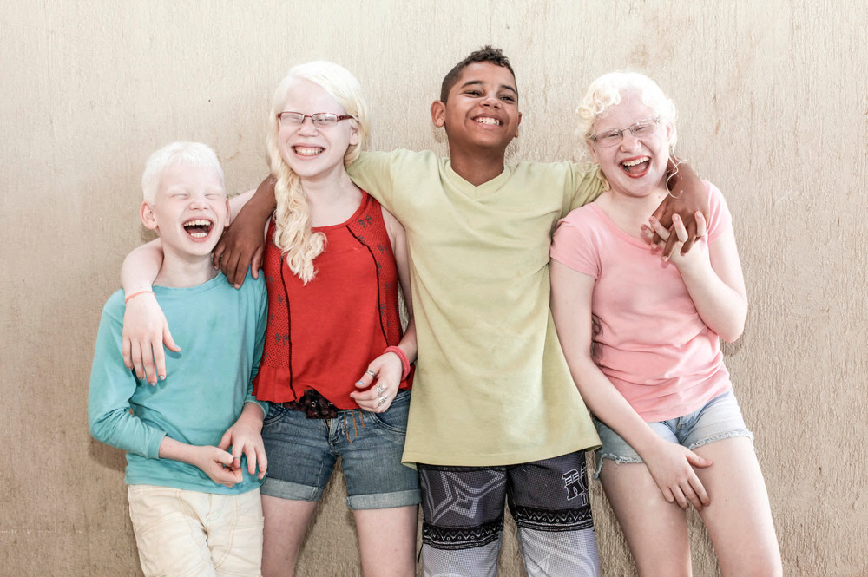
The Fernandes siblings live in Brazil.

- What do you see or observe in the picture above?

- What do you think about that?

- Suggest a biological explanation for your observations and thoughts.

Name _____________________________________ Hour _____

Showing Growth: DNA Structure and Function

Complete the tasks below to the best of your ability. This will be based on your memory and ideas – you may not use any other resources!

Before Instruction Date ____________ | After Instruction Date ____________
Draw and label a picture showing the structure of DNA. | Draw and label a picture showing the structure of DNA.
How do living things utilize the information stored in DNA? | How do living things utilize the information stored in DNA?
How and why do scientists alter DNA? | How and why do scientists alter DNA?

