Topic Review Guide: Cell Communication #2
Human Nervous System – Local Signaling
Key Concepts:
- Neuron organization and structure reflect function in information transfer
- Ion pumps and ion channels maintain the resting potential of a neuron
- Action potentials are the signals conducted by axons
- Neurons communicate with other cells at synapses
- Nervous systems consists of circuits of neurons and supporting cells
- The vertebrate brain is regionally specialized

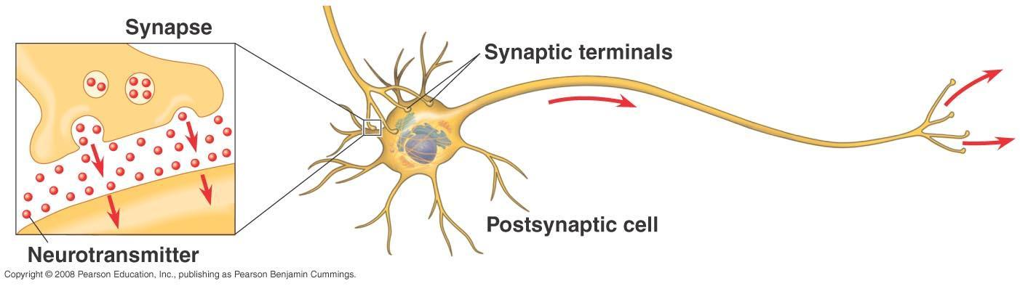
Read:
- Chapter 48

Campbell Biology Online Tasks:
- Complete the THREE activities for CH 48 and take the 15 question Activities Quiz.
- Complete the BioFlix: How Neurons Work and take the 5 question BioFlix Quiz. (Tutorial may also be helpful)
- Complete the BioFlix: How Synapses Work and take the 5 question BioFlix Quiz. (Tutorial may also be helpful)

Supplementary Resources: Click the links below for more information to help you learn more about this lesson.

- Bozeman Biology’s “The Nervous System” video.

Crash Course Biology’s video: The Nervous System
- McGraw Hill Animation: Neuron Action Potential
- Harvard Animation: Neuron Action Potential
- McGraw Hill Animation: Transmission Across a Synapse
- Harvard Animation: Synaptic Transmission
- Brainline.org: Interactive Brain Basics

Key Terms: Here is a list of key terms and concepts you will hear about and see during these podcasts and chapter readings. Get to know them! Be able to connect them to one another using a concept map.

Neuron | Dendrite | Schwann cells | Depolarization
Sensory neuron | Cell body | Myelin sheath | Hyperpolarization
Motor neuron | Axon hillock | Nodes of Ranvier | Threshold
Interneurons | Axon | Saltatory conduction | Synaptic cleft
Central nervous system (CNS) | Synaptic terminals | Membrane potential | Presynaptic membrane
Peripheral nervous system (PNS) | Synapse | Resting potential | Postsynaptic membrane
Reflexes | Neurotransmitter | Action potential | Cerebellum
Central canal | White matter | Forebrain | Dicephalon
Ventricles | Motor system | Midbrain | Thalamus
Cerebrospinal fluid | Autonomic system | Hindbrain | Hypothalamus
Gray matter | Sympathetic division | Brainstem | Cerebrum
 | Parasympathetic division | Pons | Corpus collosum
 |  | Medulla oblongata

Recall and Review: Use the lecture in the video and your textbook to help you answer these questions in your BILL.
Chapter 48: Neurons, Synapses, and Signaling
- Distinguish between the three basic types of neurons and make a drawing that illustrates the relationship between the three types of neurons
- Make a drawing of a neuron, label the anatomy of the neuron on your drawing, and discuss the function of each anatomical strucuture.
- Make a drawing of the membrane of a neuron’s axon at resting potential. Explain the distribution of ions during the resting potential and how this creates a polarity along the axon’s membrane.
- Cut out Figure #1 at the end of this handout and paste it into your BILL. Label your drawing AND explain, in your own words, what is happening at the neuronal membrane during each phase (specifically explain which channels in the membrane are open/closed during each phase, and the direction of ion movement across the membrane).
- Make a drawing of a synapse. Label the diagram AND describe in your own words, the process that leads to release of neurotransmitter, and what happens at the synapse.
- Discuss the THREE possible fates of a neurotransmitter after they are released from the receptor sites of the ion-gated channels.
- Describe the function of acetylcholinesterase, and the effect to the body if that function is inhibited.
- For the following neurotransmitters describe their secretion sites, their chemical origins, and their general effects in the human body
  - Acetylcholine
  - Epinephrine
  - Norepinephrine
  - Dopamine
  - Serotonin
  - Gamma aminobutyric acid (GABA)
- Research the drug Prozac and explain its mode of action on neurons in the brain.
- Why is the synapse a particularly good target for drugs and toxins?
- Explain why each of the following aspects of neuron structure is important to neuron function:
- many inputs, one output
- unidirectional flow of nervous signals
- polarized membrane
- “all or nothing” binary nervous signaling system
- myelin sheath
Things you should make sure you understand:
(Feel free to ask questions about them in class)
- The anatomy of a neuron.
- The mechanisms of impulse transmission in a neuron.
- The process that leads to release of neurotransmitter, and what happens at the synapse.

Learn More: For more information on the human nervous system, use the links below:
Figure #1 – cut it out and paste in your BILL for question #4
