AP Biology Topic Review Guide: #3
Human Immune System – Direct Contact Signaling
Key Concepts:
- In innate immunity, recognition and response rely on shared traits of pathogens
- Innate defenses are nonspecific
- In acquired immunity, lymphocyte receptors provide pathogen-specific recognition
- Acquired immunity defends against infection of body cells and fluids
- Disruptions in immune system function can elicit or exacerbate disease

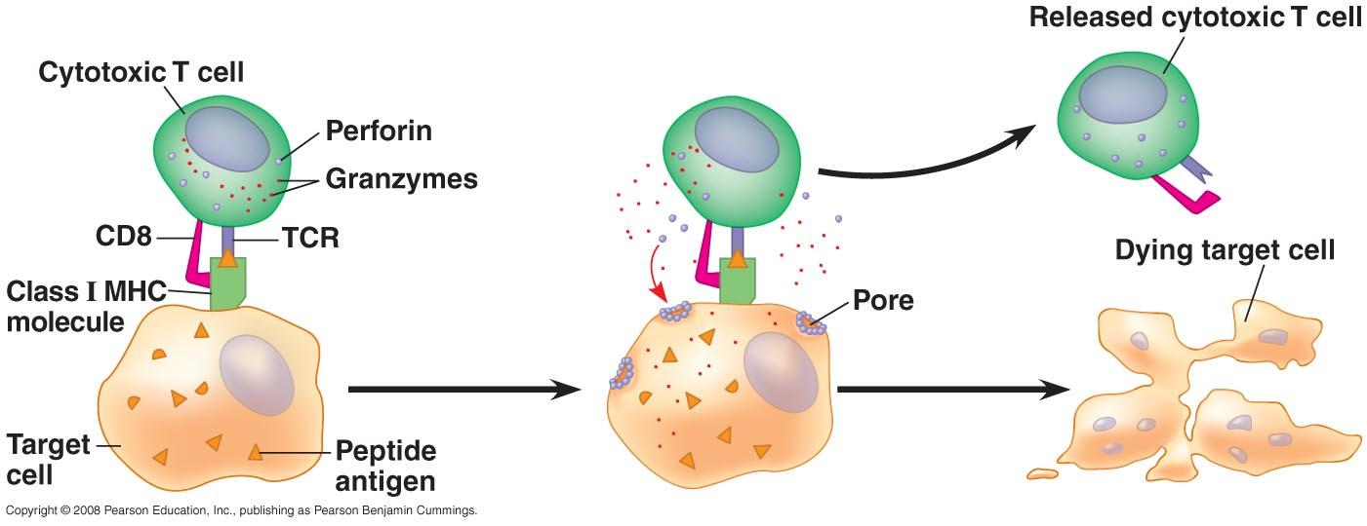

Read:
- Chapter 43
Campbell Biology Online Tasks:
- Mastering Biology chapter 43
Supplementary Resources: Click the links below for more information to help you learn more about this lesson.

- Bozeman Biology’s “The Immune System” video.
- Crash Course Biology’s video: Your Immune System: Natural Born Killer
- McGraw Hill Animation: The Immune Response
- WH Freeman: Humoral Immune Response
- WH Freeman: Cellular Immune Response

Key Terms: Here is a list of key terms and concepts you will hear about and see during these podcasts and chapter readings. Get to know them! Be able to connect them to one another using a concept map.

Immune system | Inflammatory response | Antibody | Active immunity
Pathogen | Histamine | Heavy and light chain | Passive immunity
Innate immunity | Mast cells | Variable region | Vaccination
Acquired immunity | Natural killer cells | Class I & II MHC molecules | Allergens
Phagocytosis | Lymphocytes | Clonal selection | Autoimmune disease
Macrophages | B cells (plasma, memory) | Primary immune response | Immunodeficiency
Neutrophils | T cells (Helper, Cytotoxic, Memory) | Secondary response | Acquired immunodeficiency syndrome (AIDS)
Interferons | Thymus gland | Humoral immune response
Complement system | Antigen | Cell-mediated immune response | HIV

Recall and Review: Use the lecture in the video and your textbook to help you answer these questions in your BILL.
- Distinguish between innate immunity and acquired immunity.

- Describe how your skin, mucous membranes, and secretions create a first line of defense for our bodies. (These are forms of innate immunity known as barrier methods.)

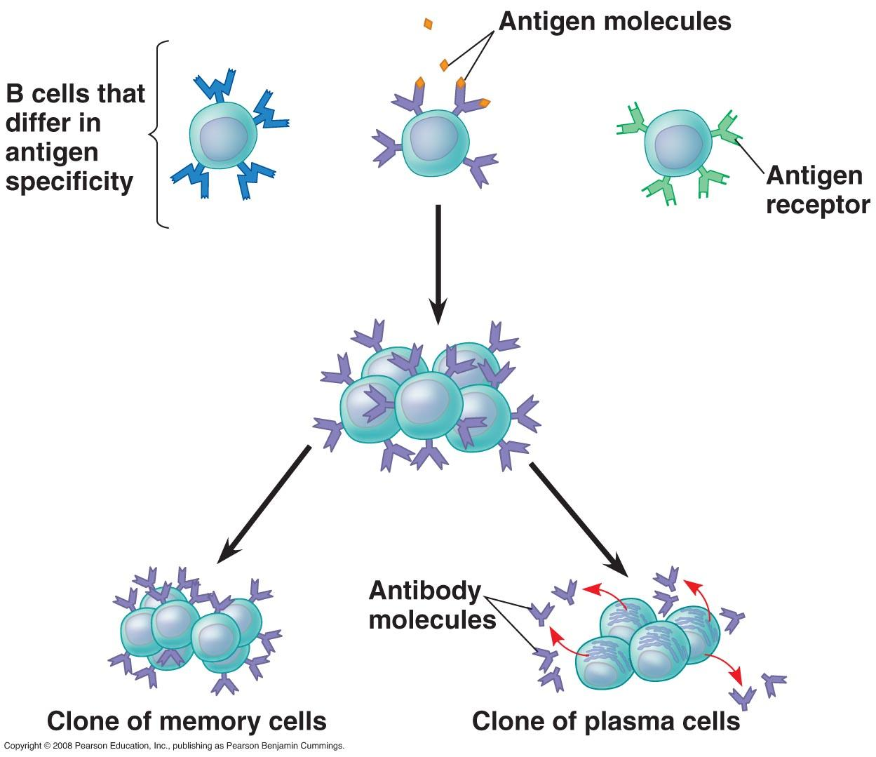

- For each method make a drawing and describe how each of the following second lined of internal defenses protects the body from disease:
  - Phagocytic cells – neutrophils, macrophages
  - Antimicrobial proteins - interferon, complement system
  - Inflammatory response - histamine
  - Natural killer cells – MHC, cytotoxic T-cells

- Discuss the differences between B and T cells relative to their activation and actions.

- Distinguish between an antigen and an antibody.

- Describe how antigens are recognized by immune system cells. Include:
  - an explanation of the role of major histocompatibility complex molecules (MHCs).
  - an explanation of clonal selection.

- Create a flow chart diagram to illustrate and discuss the differences between humoral and cell-mediated immunity.

- Explain why a secondary infection is usually less severe than a primary infection of the same pathogen.

- Explain why Helper T cells are central to immune responses and why the HIV virus is so difficult to defeat.

- Discuss how antibiotics, vaccines, and passive immunity are used to aid the human body in protecting itself from foreign pathogens.
Things you should make sure you understand:
(Feel free to ask questions about them in class)

- Several elements of an innate immune response.
- The differences between B and T cells relative to their activation and actions.
- How antigens are recognized by immune system cells.
- The differences in humoral and cell-mediated immunity.
- Why helper T cells are central to immune responses.
- The causes, symptoms, and treatments of immune system disorders.
- How and why vaccines work (and why they don’t always).

Learn More: For more information about the human immune system, use the links below:
National Institute of Allergy and Infectious Disease: Immune System
HYPERLINK "http://www.niaid.nih.gov/topics/immunesystem/Pages/default.aspx"

